Client Relationship Management

Overview of the RDI-Selkirk College Client Management System (CMS)

## Overview

The CRM is based on Sugar CMS, a popular web based, client relationship management application. The intent of this CRM is to facilitate effective organization, population, maintenance and reporting of client relationships and delivery of related supports (i.e. consultations, advisory services, use of equipment, direct support, and training) by Selkirk College staff to communities and companies. This CRM consists of modules, each of which represents a specific functional aspect of CRM, such as Clients, Users, Projects, Tasks and Documents.  For example, the Client module enables you to create and manage activities, projects, and services related to client accounts.

## Logging in and Your Profile

SelkirkCRM is accessed at this URL:

<http://rdi-connect.sgrc.selkirk.ca/SelkirkCRM/>

An email will be sent to you with a user name, a system generated password and a link to SelkirkCRM.

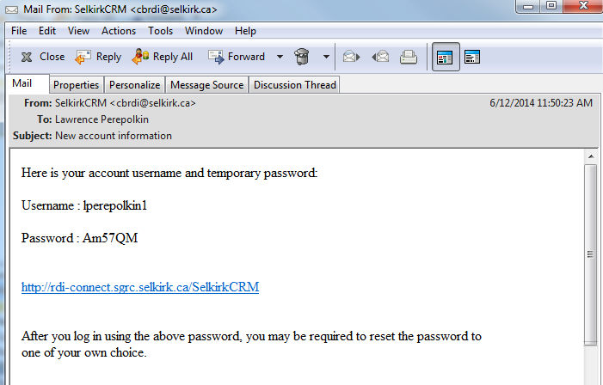

1. Click on the link <http://rdi-connect.sgrc.selkirk.ca/SelkirkCRM/>

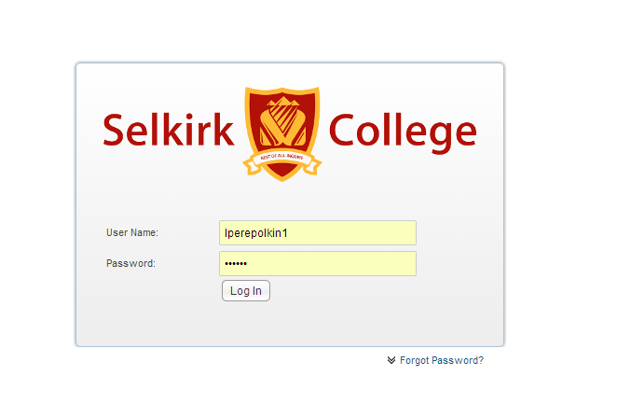

1. Login using the user name and password given in the email.

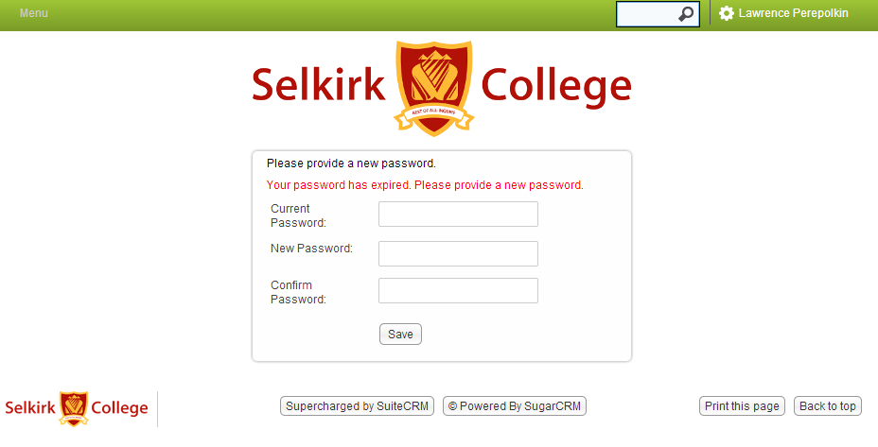

1. Enter the password supplied in the email for the current password and choose a new password.
2. After logging in you can update your profile by clicking your user name.

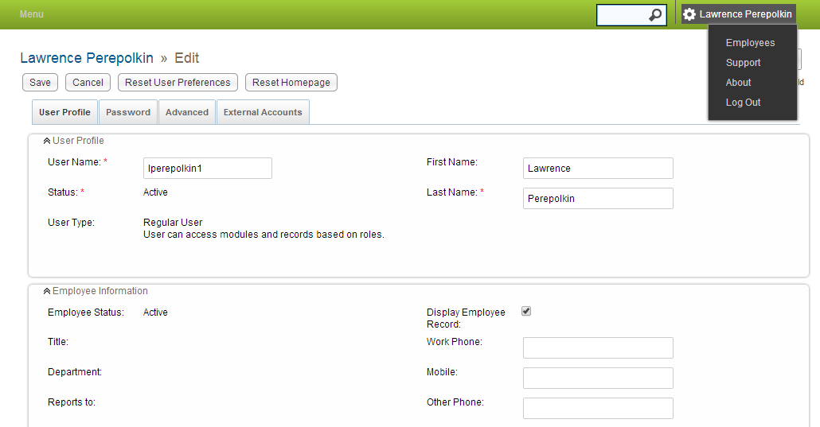

## Core Features

* Client Module
* Contacts Module
* Activities Module
* Documents Module
* Projects Module
* Partners Module
* Milestones Module
* Funding Module
* Services Module
* Business Cases Module
* Reporting Module
* Exporting Data

## Accessing Core Features

Modules are accessed through the main menu.

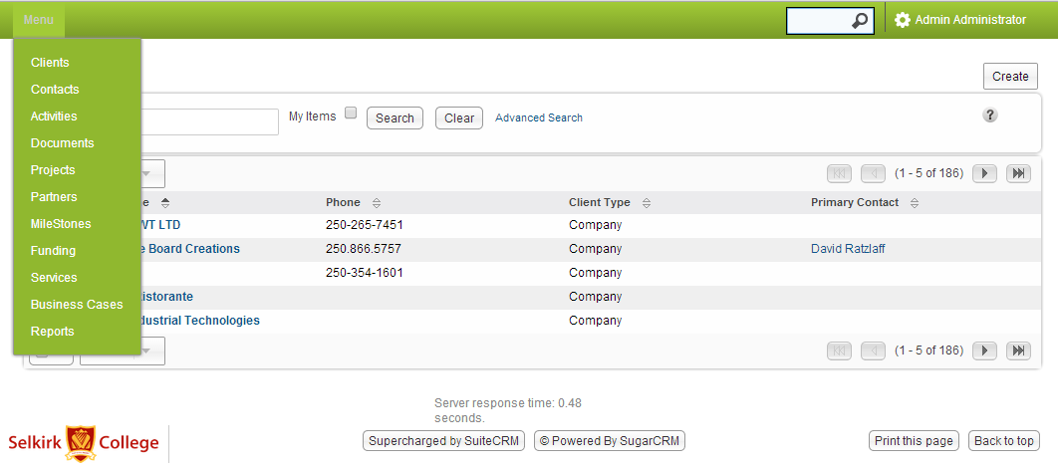

## Client Module

Client module is used to create and manage client accounts.

* Clients are companies, organizations, local government (option to tag as partner)
* A client contains client information such as name and address and attributes to distinguish them as companies, organizations, K-12 & post-secondary institutions, and local government
* Clients can be associated with other records such as documents, services, activities, contacts and users.
* Each client has a primary contact and primary Selkirk College ‘user’ associated.

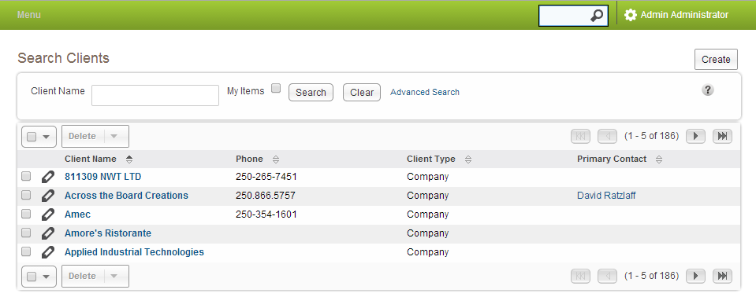

#### To Create a Client

Click the Create button in the top right corner.

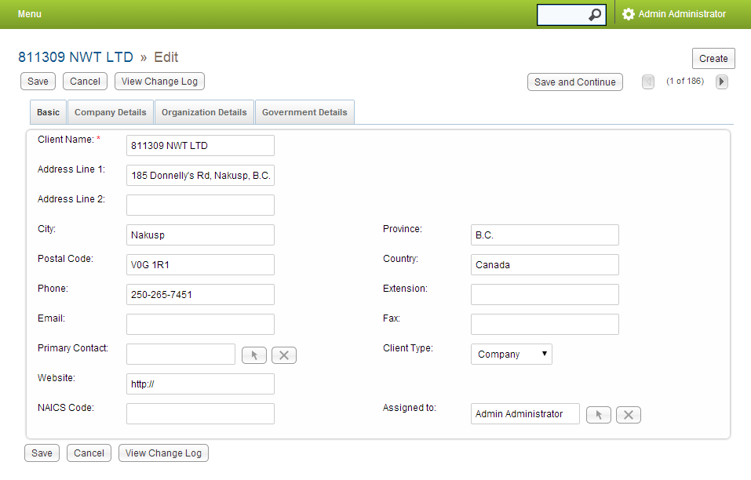

Associate a primary contact by clicking the arrow button. Fill in the rest of the data items.

Click the Save button. After saving a client, you can associate documents, services, activities and contacts.

#### To Associate a Document With a Client

The Create/Select button allows you to associate a previously entered document. You can create a new document or select an existing document. Choose the Select option.

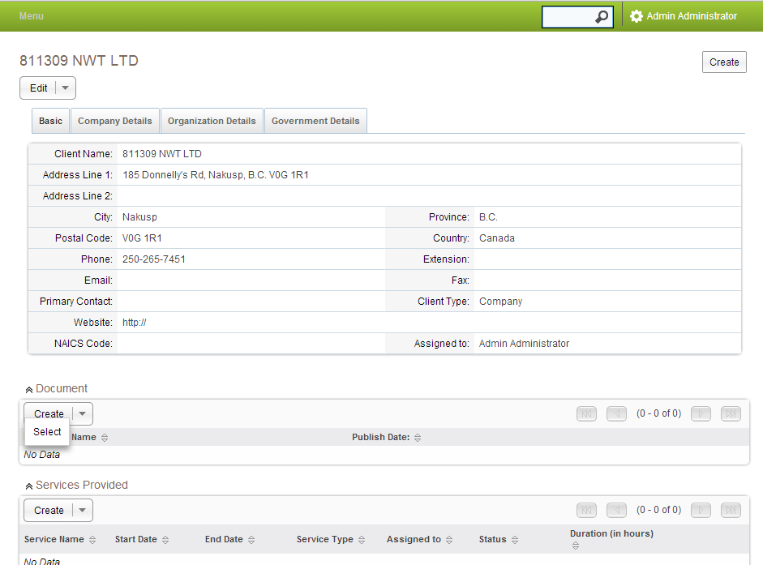

A pop up window displays, allowing you to search or select a document:

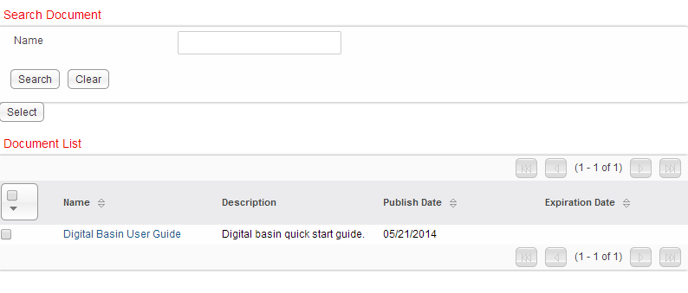

Click on “Digital Basin User Guide.” Follow the same steps to create, select and associate services, activities and contacts with a client.

## Contact Module

Contact module is used to create and manage contacts.

* A contact contains information such as name, title, email, phone number and address.
* Contacts can be associated with many clients and many activities.

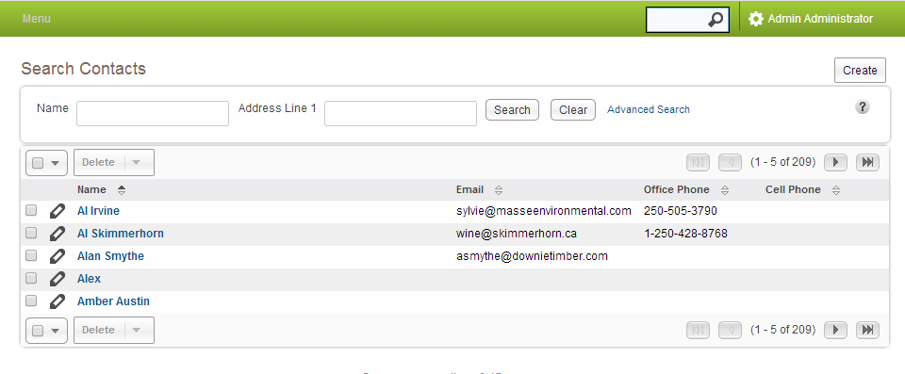

#### To Create a Contact

Click the Create button in the top right corner.

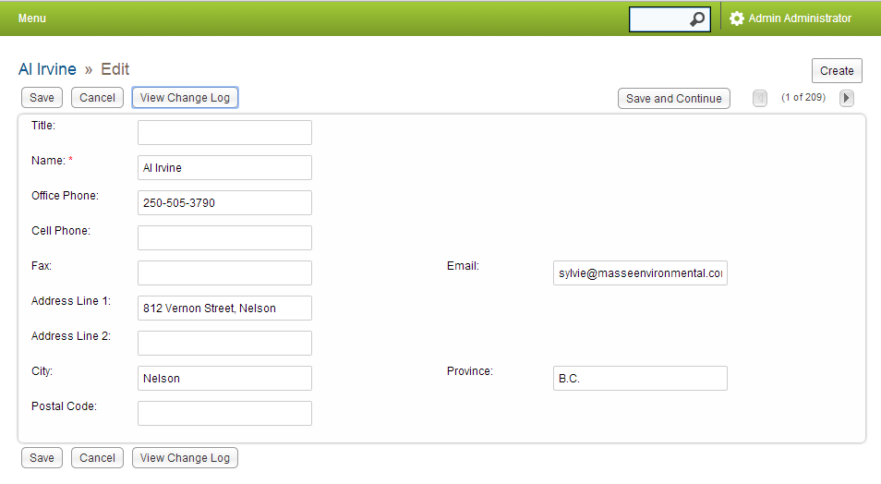

Populate fields and press the Save button.

After saving, associate clients and activities. Using the Create/Select buttons.

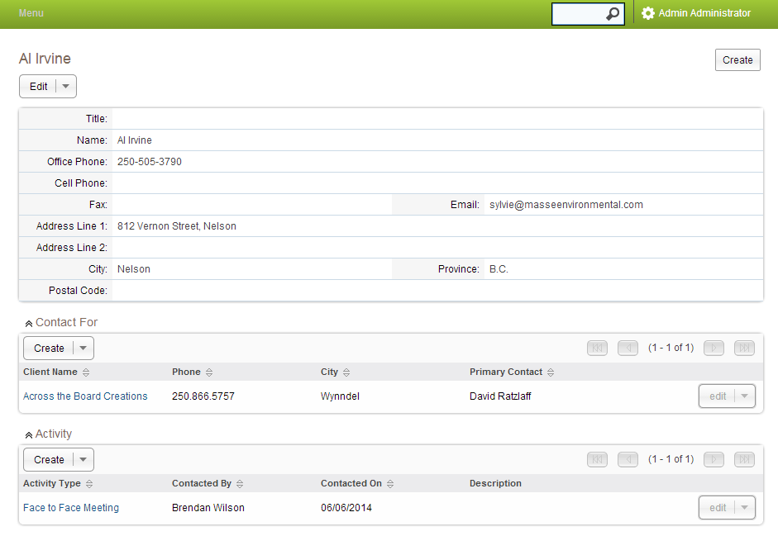

## Activities Module

An activity is an interaction with clients such as a phone call, a meeting, or an email.

An activity captures who (which user/employee) , interacted with which contact and client on a date.

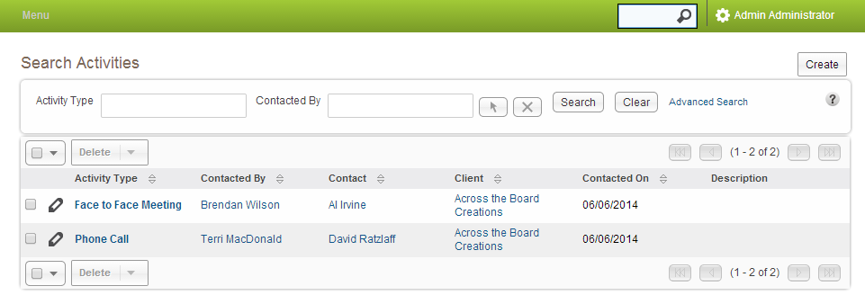

#### To Create an Activity

Click the create button in the top right corner.

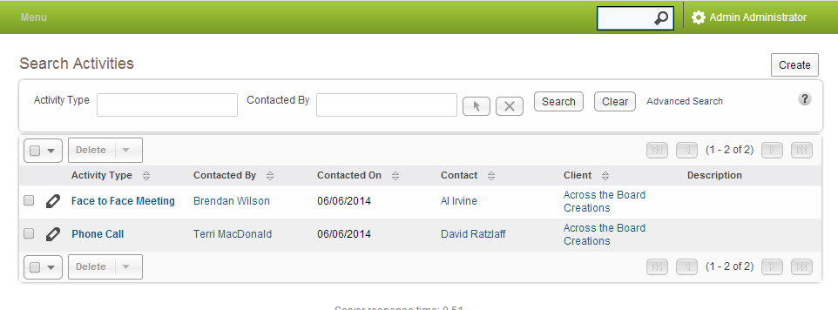

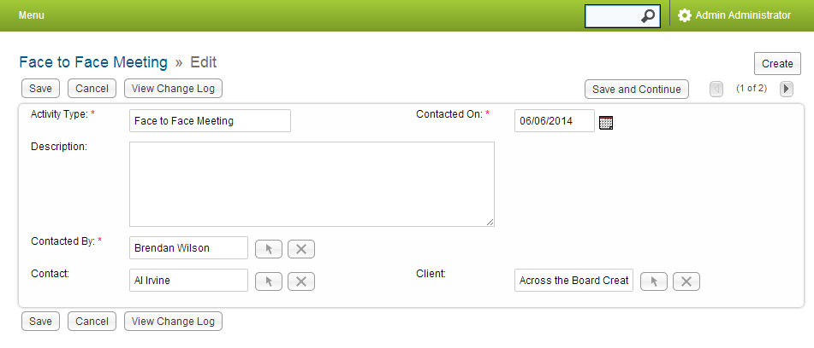

Use the arrow buttons to associate a user, contact and client.

After you are finished press the save button.

## Documents Module

* Documents Module is used to create and manage files that you associate with clients, projects and services.
* Documents Module can be used to create templates for frequently used document formats.

#### To Create a Document

Click the create button in the top right corner.

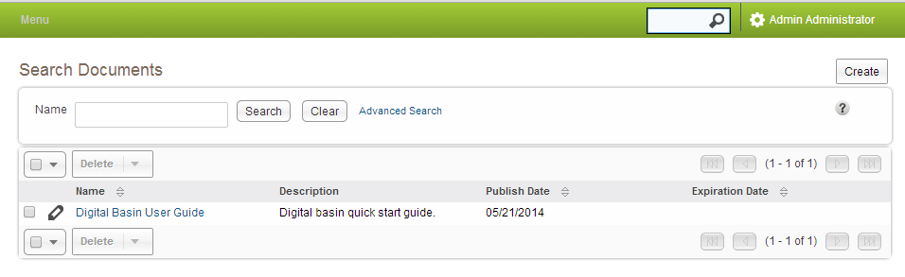

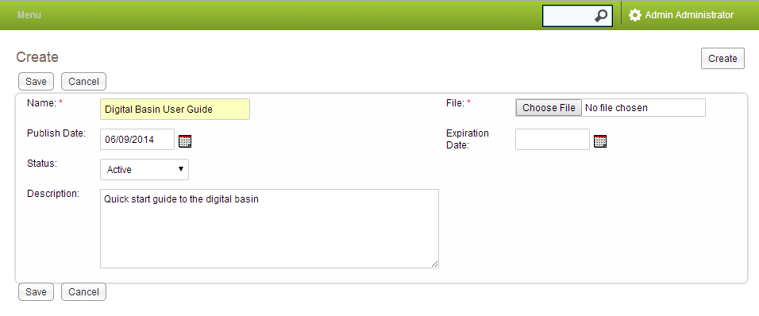

Click the “Choose File” button to upload a file. After you are finished press the save button.

Use the Create/Select buttons to attached the document to a one or more clients, projects or services.

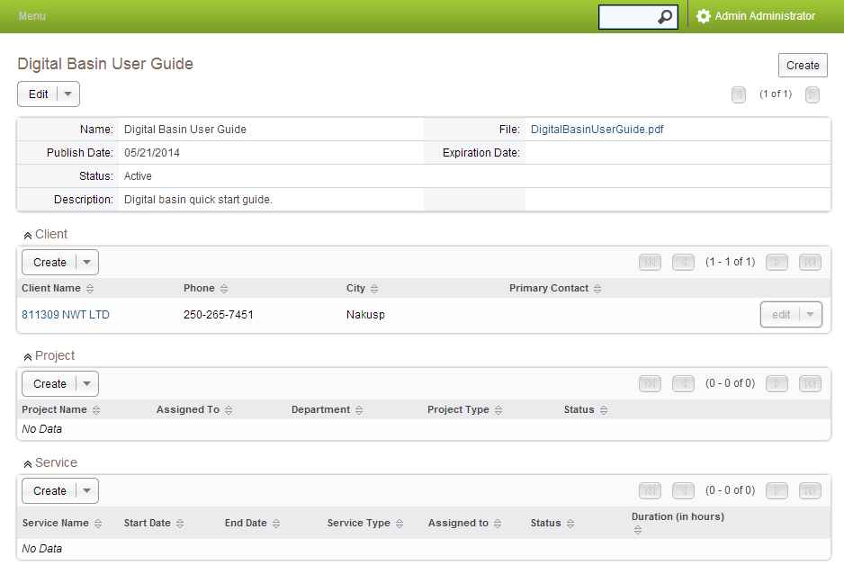

## Project Module

1. Projects Module is used to create and manage projects.
2. Projects have a type attribute of (In-Class, Internship, Federally Funded, Provincially Funded…)
3. Projects can have many associated records like documents, business cases, partner contributions, milestones, services, funding records.
4. When a milestone is reached an email notification is sent to project manager.
5. Every project is assigned to a user. The assigned user is the project manager. By default, this is the user who created the project.
6. Users can create, manage and duplicate projects.
7. Multiple services can be defined for each project.
8. Each project task must be assigned to a user.
9. Services capture the amount of time in hours the assigned user spent on the task and for which client.

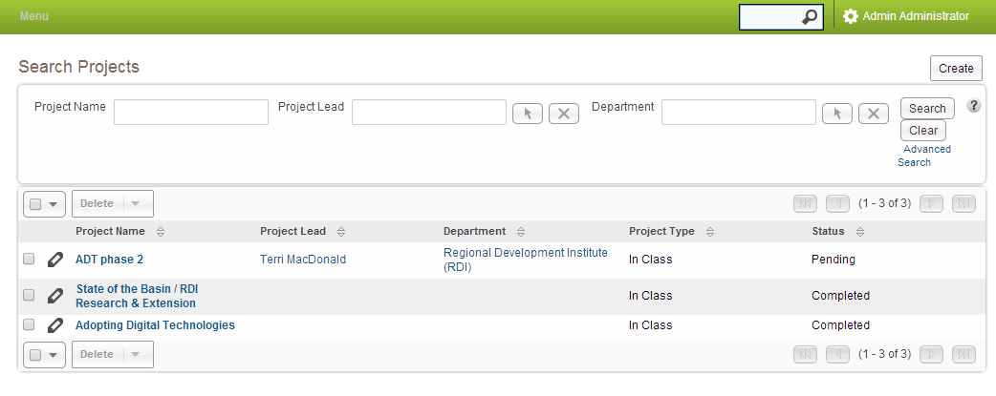

#### To Create a Project

Click the Create button in the top right corner.

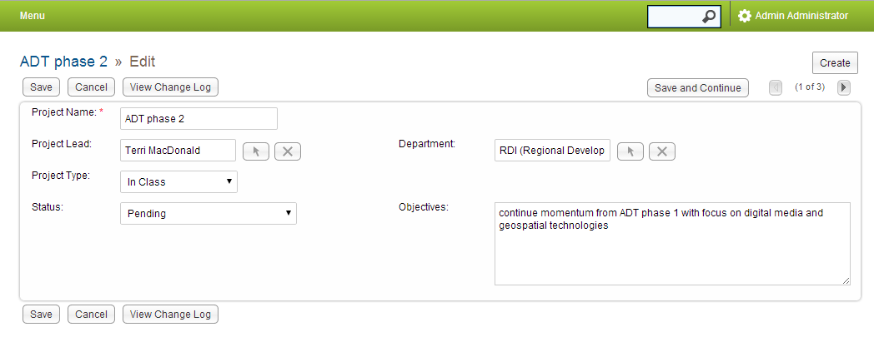

Enter a Project Name.

Assign the project to user and department by clicking the arrow button.

After saving the project you can associate documents, business cases, partner contributions, milestones, services and funding.

## Partner Module

The partner module records a contribution received from a partner for a project.

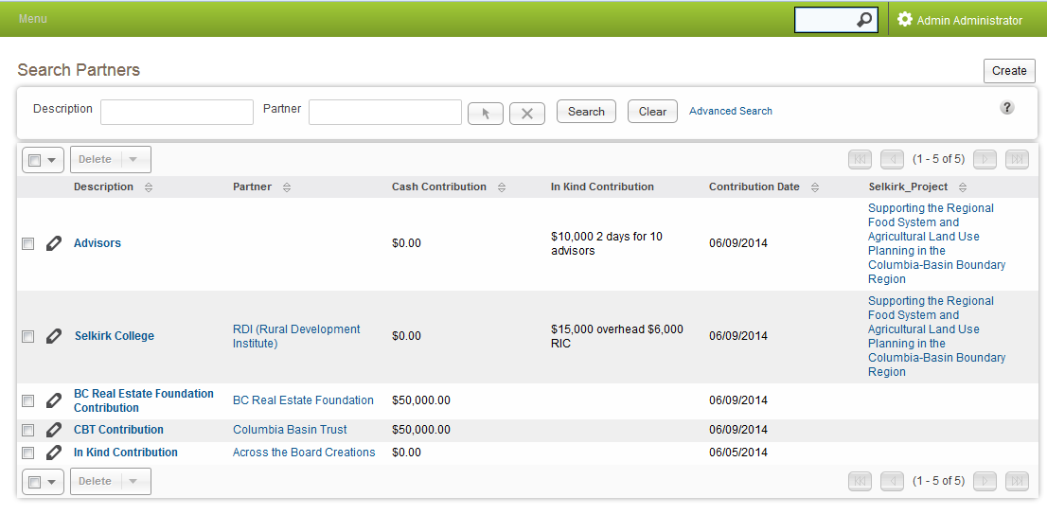

#### To Create a Partner

Click the Create button in the top right corner.

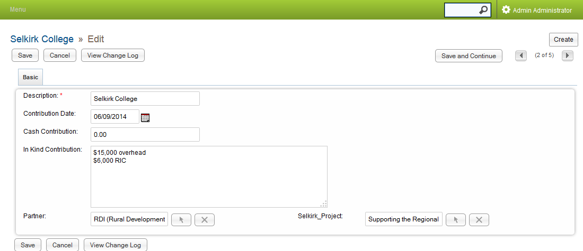

Use the arrow buttons to associate a contribution to a partner and a project.

## Milestones Module

Milestones Module is used to create and manage significant date related events in the life time of a project. When a milestone is reached an email notification is sent to project manager.

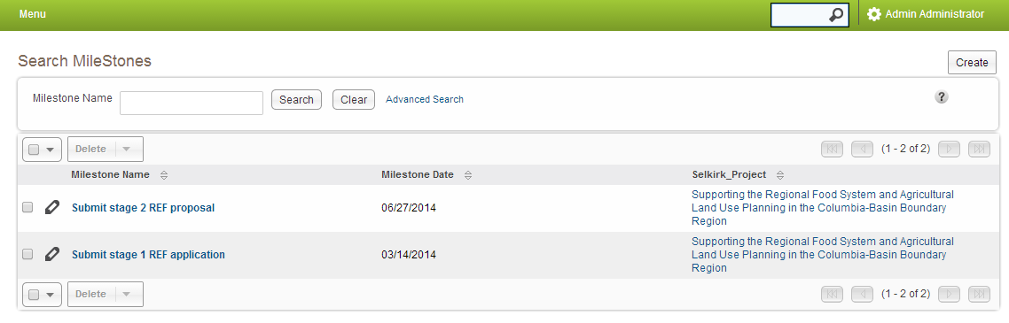

#### To Create a Milestone

Click the Create button in the top right corner.

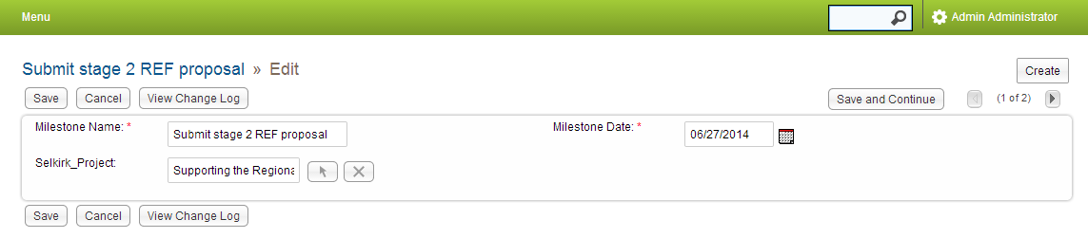

Enter a milestone name, date and associate a project using the up arrow.

## Funding Module

The funding module records the source of funding , amount, funding start and end dates for a project.

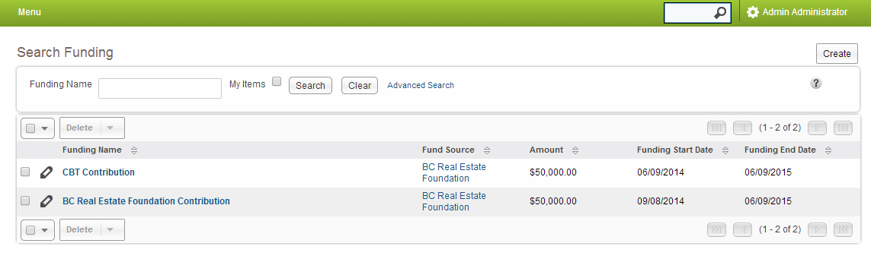

#### To Create a Funding source

Click the Create button in the top right corner.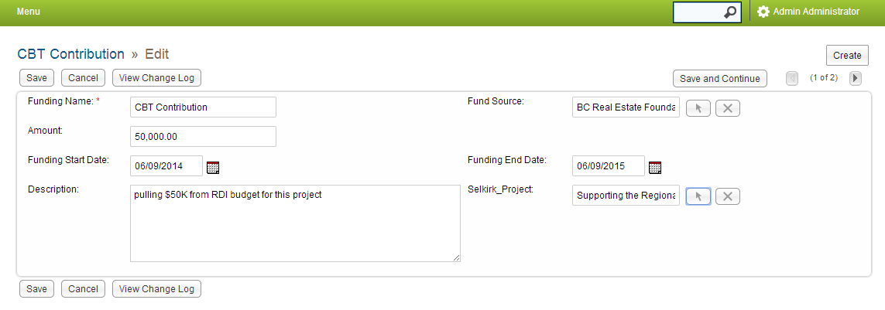

Fill in the fields and associate a funding source, project using the up arrows.

## Services Module

Services Module is used to create and manage time related activities associated with projects and clients. Services include: Awareness/Outreach, Consultation, Proposal Development, Data Requests, Advisory Services, and Direct Support.

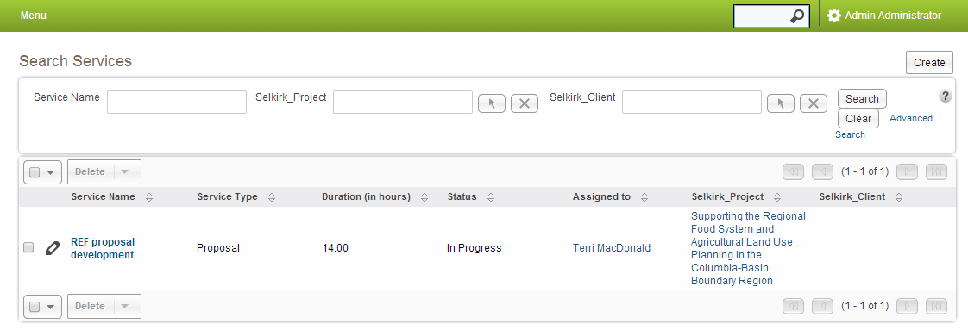

#### To Create a Service

Click the Create button in the top right corner.

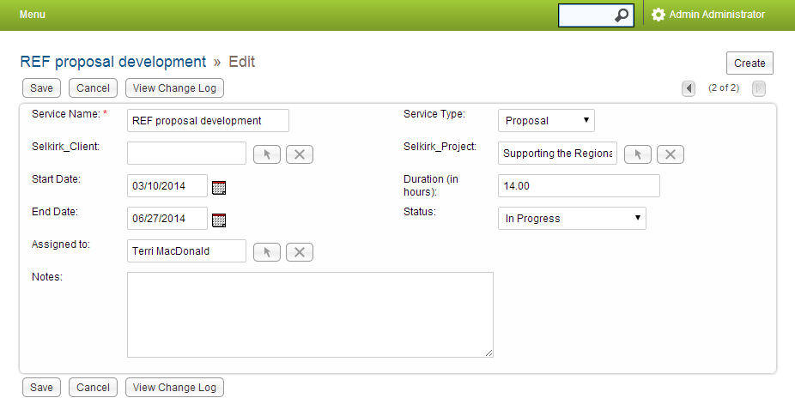

Enter a Service Name.

Using the arrow buttons associate the service to a User, Client, and a Project.

Enter day the task took place and the amount of time in hours in the task took.

Click the save button.

## Business Case Module

Business Case module is used to capture the reasoning and justification for a proposed project on the basis of its expected benefits.

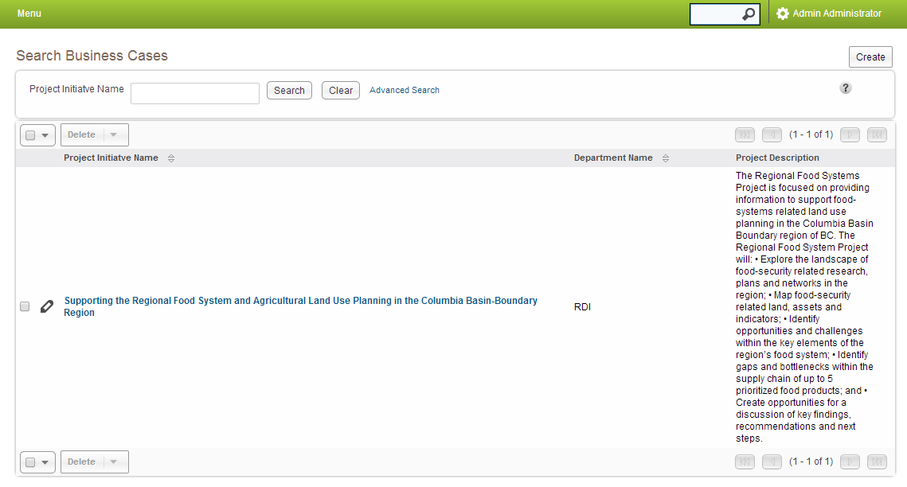

#### To Create a Business Case

Click the Create button in the top right corner.

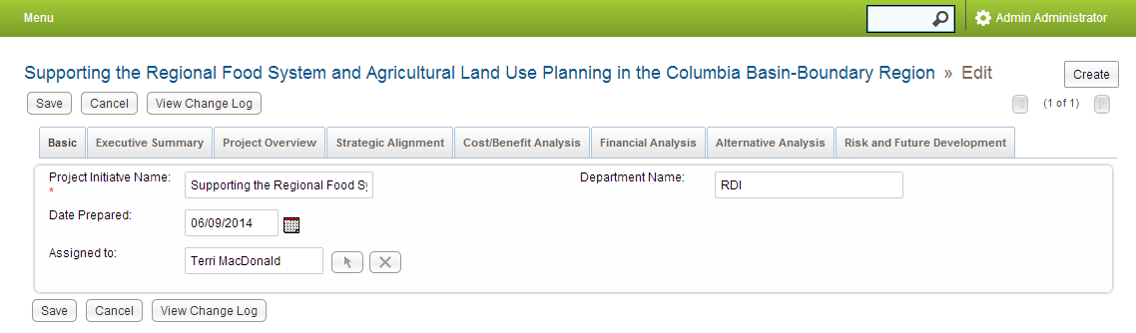

Filling in the fields. Click on tabs and fill in additional information justifying a project. Click that save button.

After saving, associate the business case with a project and an approval.

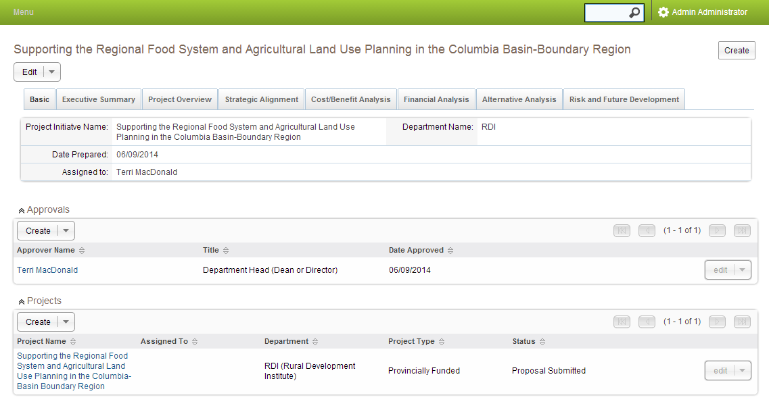

## Approvals Module

The approvals module records who has approved the business case. A new approval record needs to be created for each approving user.

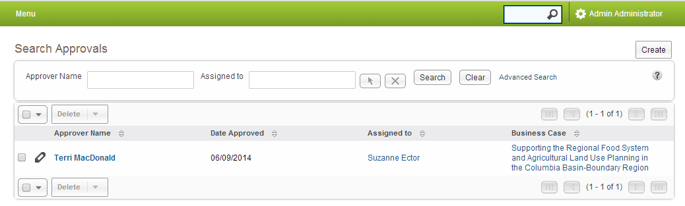

#### To Create an Approval

Click the Create button in the top right corner. 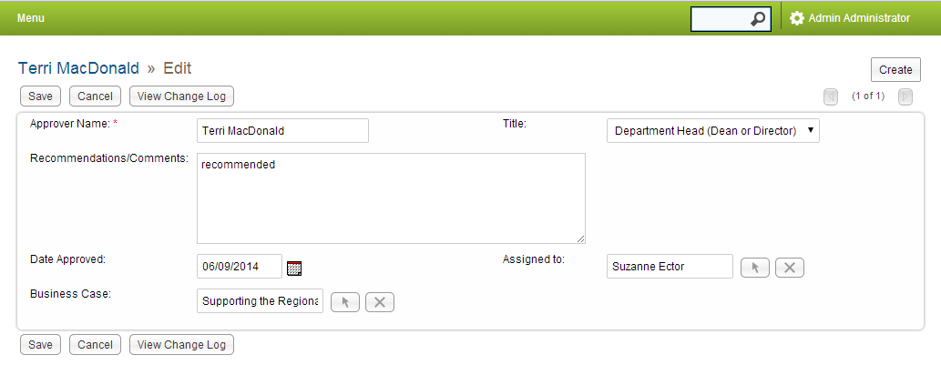

Fill in your name. Use the up arrow to select a business case. Use the up arrow to select the next user to approve the business case. When the approval is saved an email notification is sent to the assigned user. Click the Save button.

## Reports Module

* Reports Module is used to create adhoc reports.
* Users can create their own set of reports.
* Users can choose from a predefined set of reports.
* Reports can be created on modules and associated modules.
* Modules can be joined on related fields.
* Reporting can be by hour, user, project, task client type and/or department.
* Fields items can be grouped (rolled  up) and counted or summed on grouped fields.

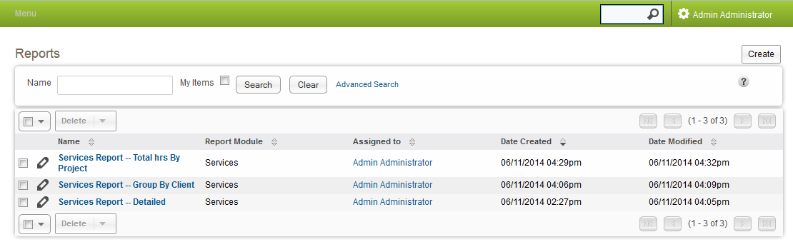

#### To Create a Report

Click the create button in the top right corner.

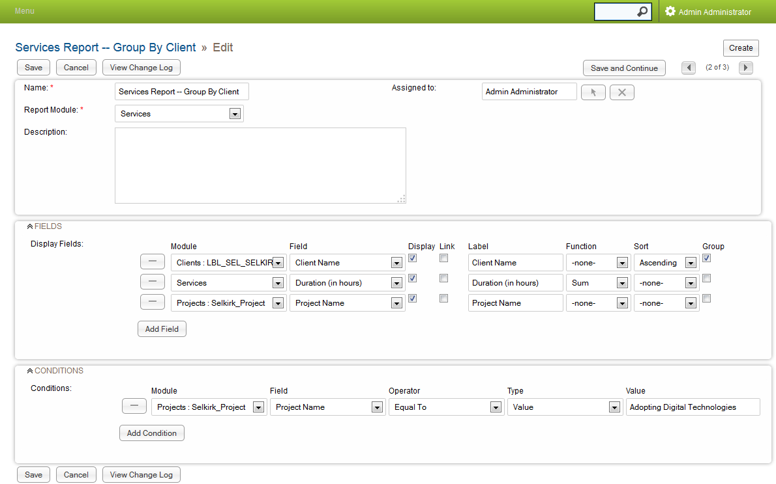

Enter a Report Name.

Choose a Report Module

Add the fields to report on.

Choose columns to sum and group on.

Save the Report.

#### Download a PDF of the Report

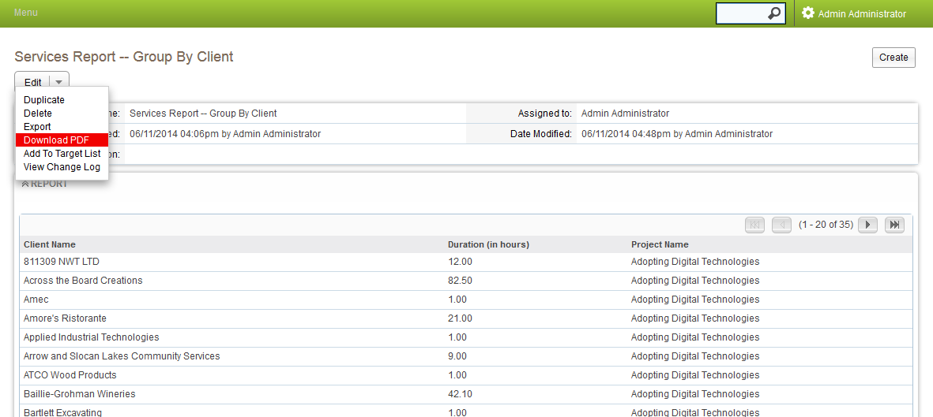

This is what the downloaded PDF report looks like: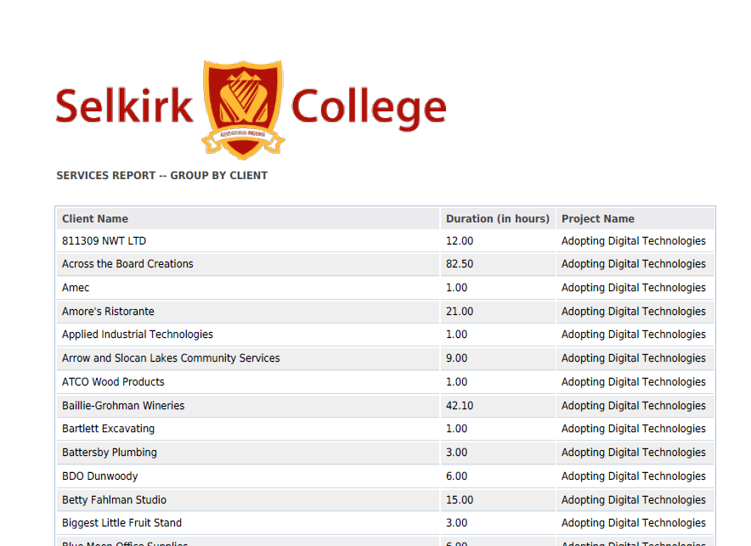

#### Exporting Data

* Data can be exported from all modules in PDF,  or CVS (Comma Separated Value)  formats.
* Data generated by reports can be exported.

#### To Exporting Data

Click the select all option. 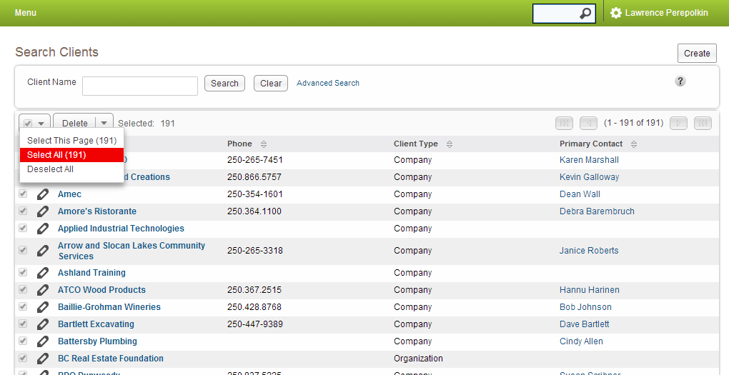

Then choose the Export option

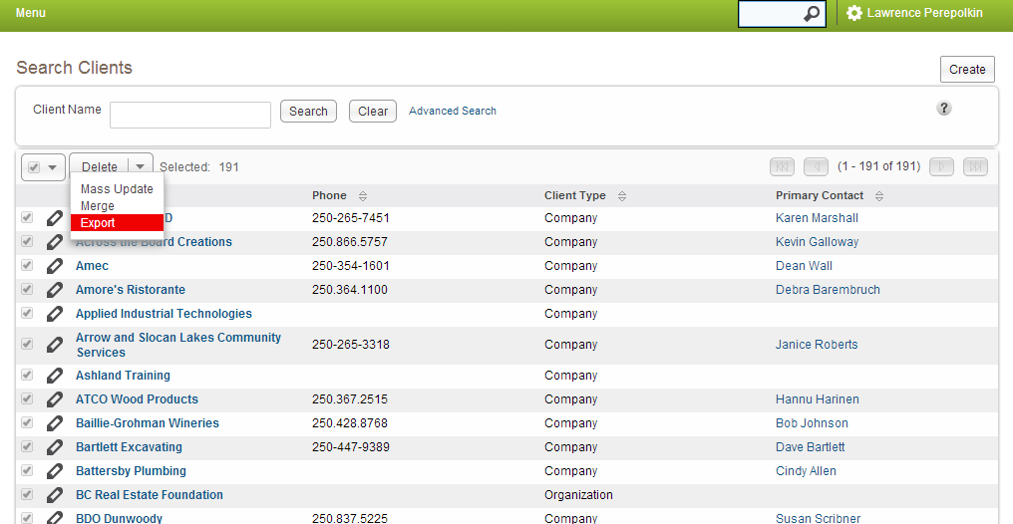

## Next Steps

* Refine categories based on Selkirk ARI stakeholder feedback
* Refine permissions parameters based on Selkirk ARI stakeholder feedback
* Explore opportunities for development / integration of existing ARI reporting and RDI intake mechanism